Lab 9 Star Lab

Joshua Pollock

11/15/16

Lab section 1

1. **Problem Statement**

The problem given to us by the lab was to create 3 functions that would read a file and from that data draw something using the turtle commands. These three functions will be named:

* read_coords(file)
* plot_by_magnitude(picture_size, coordinates_dict, magnitudes_dict)
* plot_plain_stars(picture_size, coordinates_dict)

There are no assumptions needed to be made but, there are quite a few constraints that this lab

has. These constraints are:

* The file must be closed after use
* Star_size may not exceed 8. If greater than 8, it will be set to 8.
* Star_Size should be calculated by 10/(magnitude+2)
* If a star has more than 1 name, each name will be stored in the 3rd dictionary

With these in mind we can begin planning our code.

1. **Planning**

We had no idea how to start off with this lab. We figured it would be a good idea to refresh our knowledge on file handling, and began by looking at the commands related to file handling and the turtle module. After getting our refresher on this, we began by thinking of what the lab was asking and what we could use to solve the problem. We started to lay a framework of what we wanted to accomplish in the lab, and tried to start writing code. Sadly, we had much more difficulty then we planned for in class time. Throughout the week, we had begun trial and error in our code. Eventually we had overcome our difficulties and finally figured out how to read the file. After figuring this out, the rest of the coding was a breeze.

1. **Implementation and Testing**

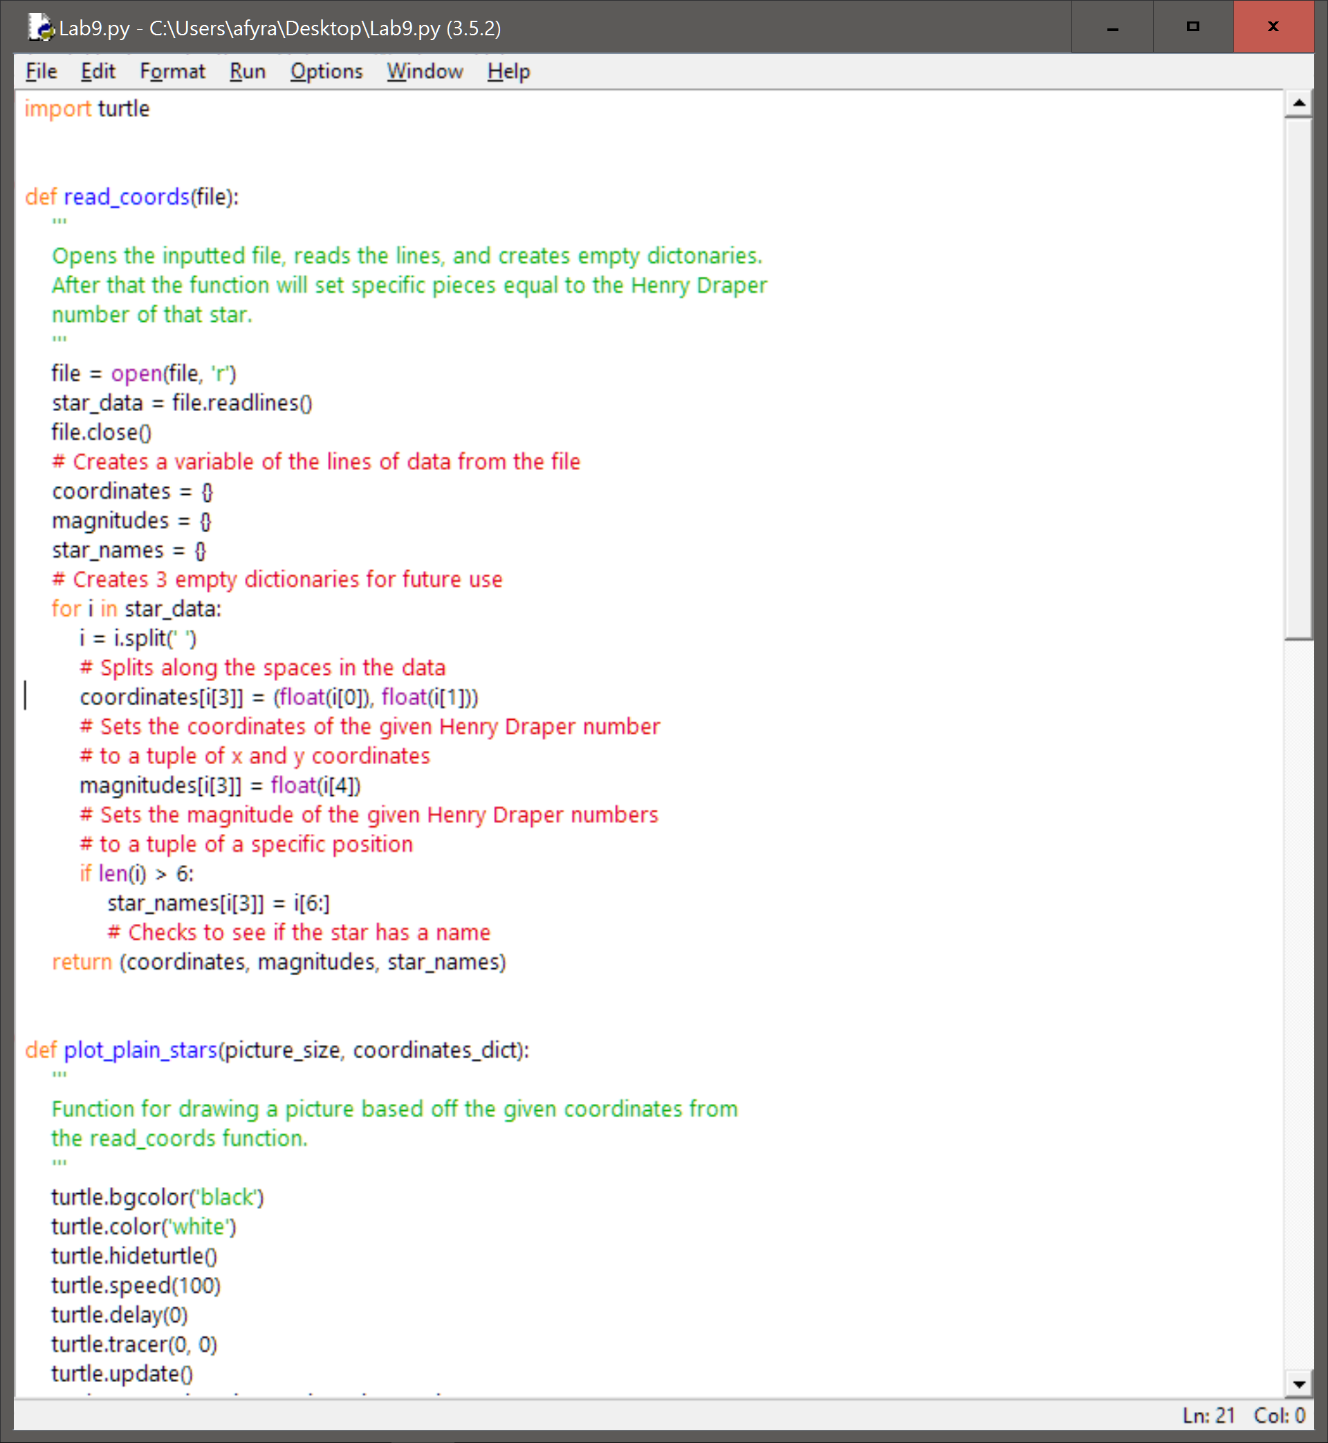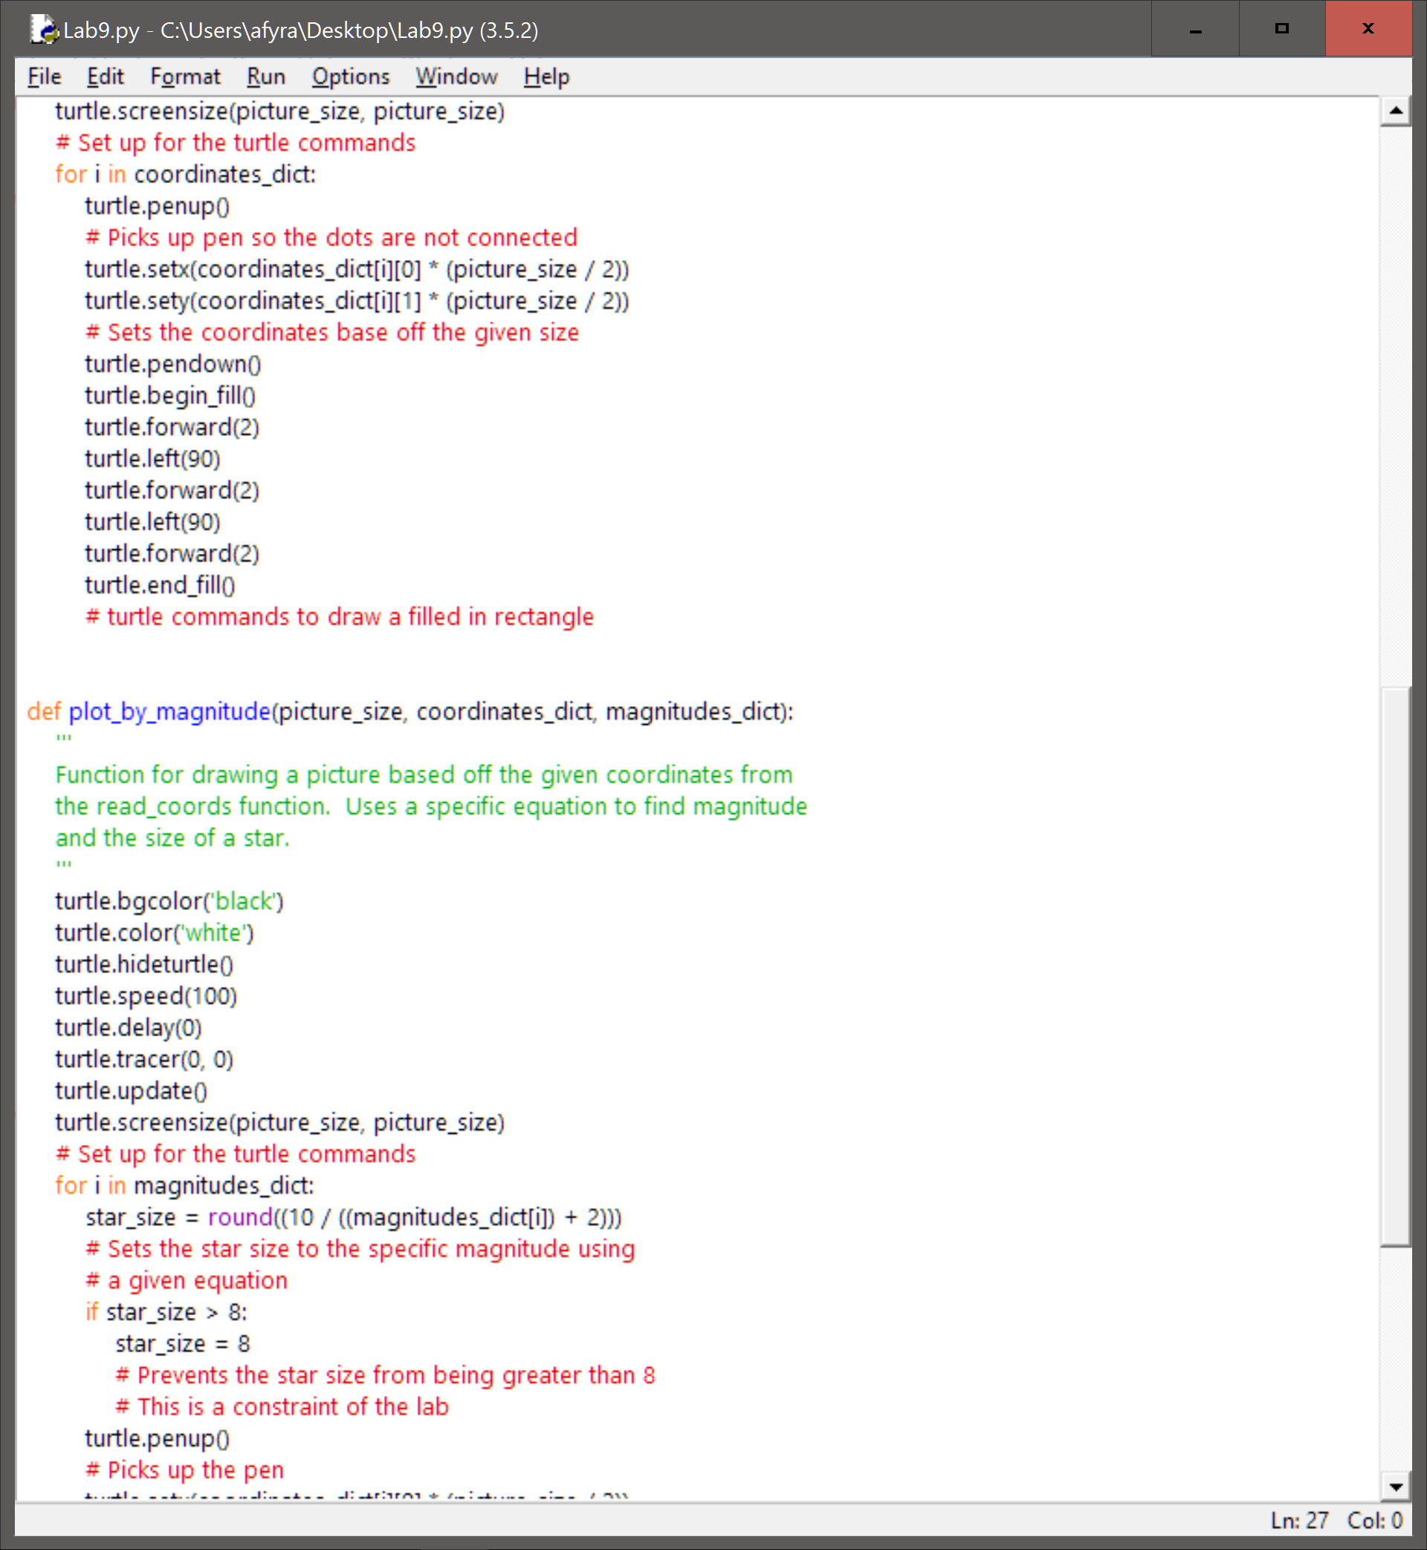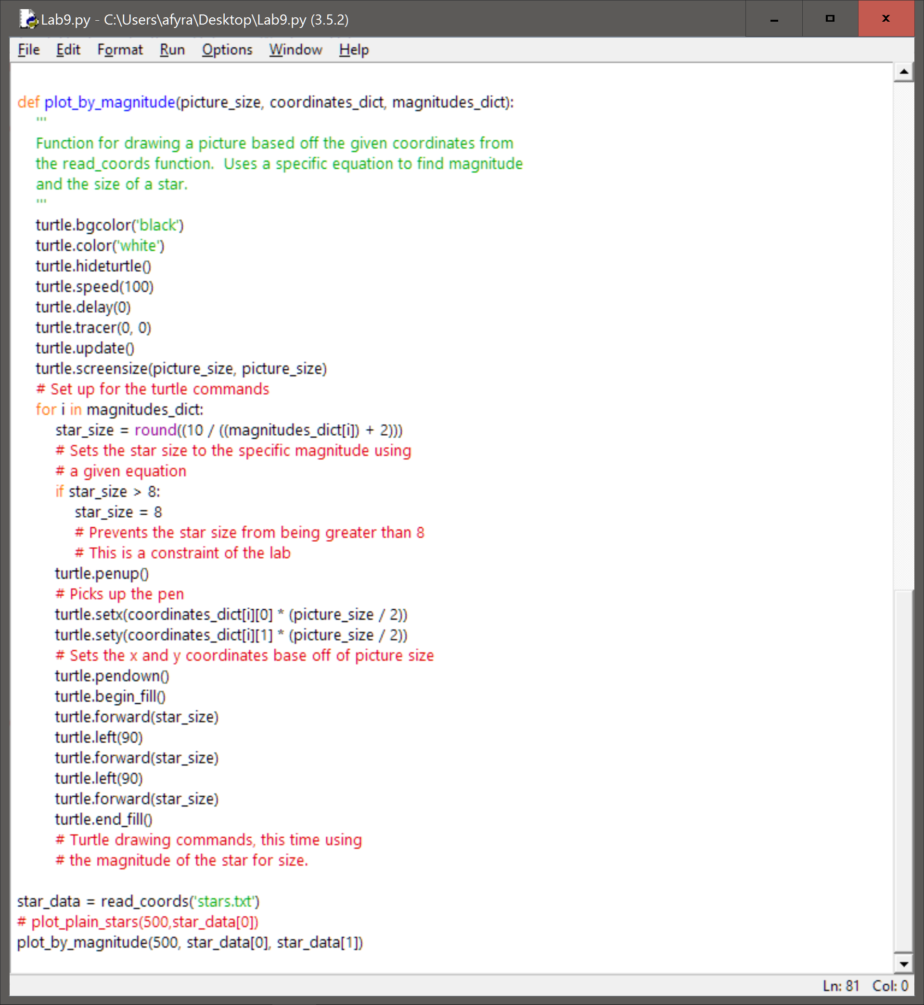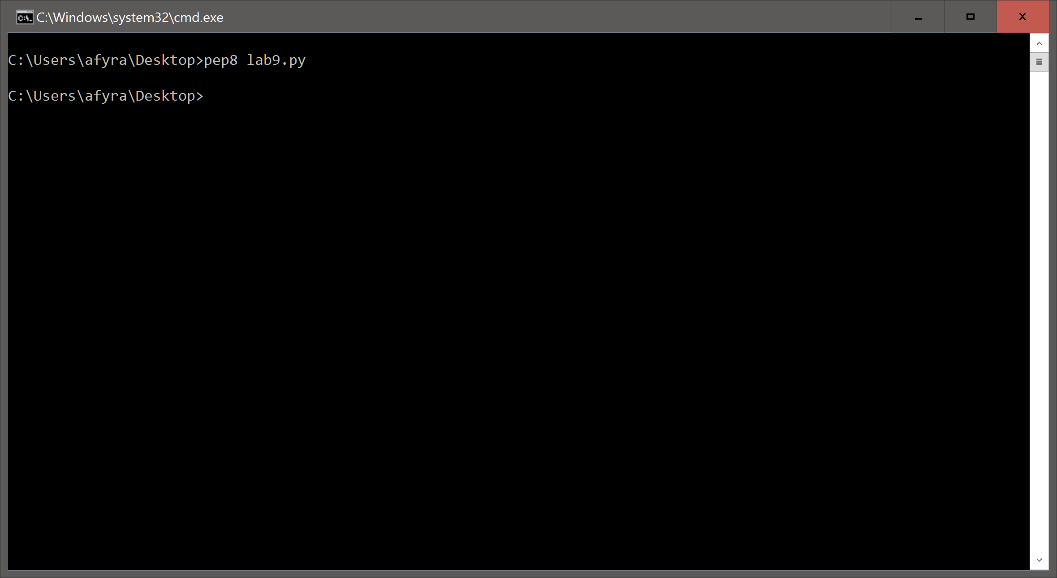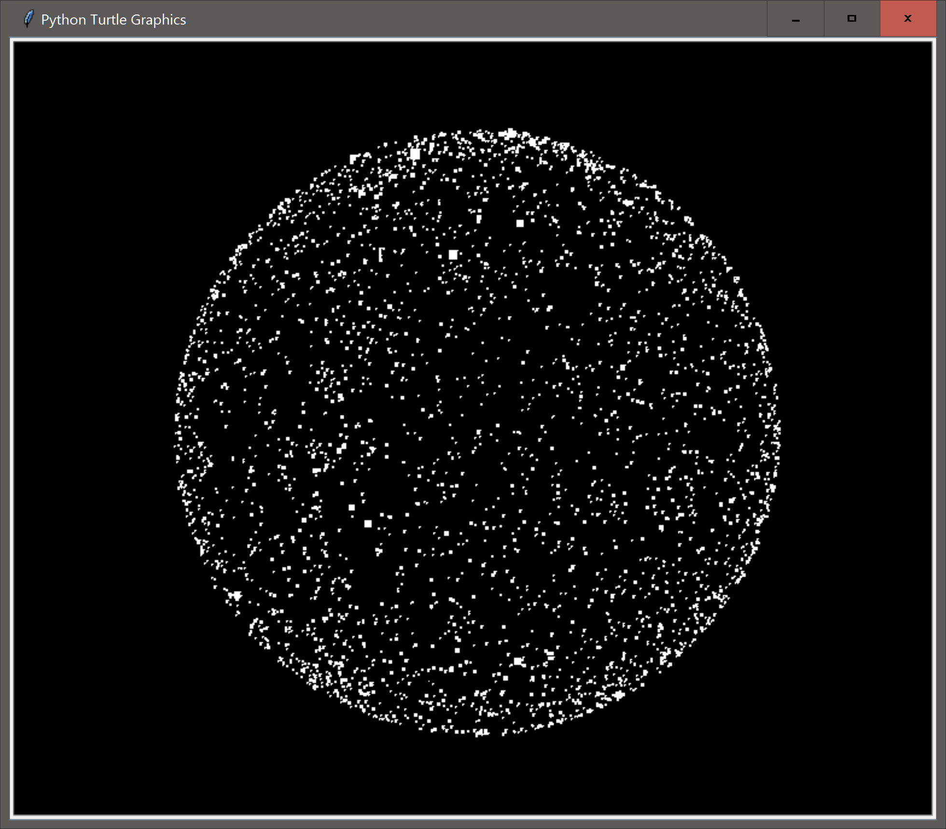

1. **Reflection**

Overall I am quite happy with how the code turned out. I was able to speed up the turtle drawing to finish the picture quite fast. The code solves the problem that was given, and is able to draw a picture based on the information from the file. One area for improvement is the length of the code. The length could be greatly reduced by using a while loop to draw the rectangles instead of using separate commands. Another area of improvement is in the reading aspect of the code. When it reads the names of the stars it does not remove the ‘\n’ at the end of the names. I do not know of a way to get rid of this currently. The final issue with the code lies within the picture_size. If the picture size is too low, the stars will simply not be drawn. I do not know if this is a limitation within turtle or a limitation within my code. Even with these slight issues, I am still very happy with the way the code turned out.